1. **Ultrasonic sensor operation**

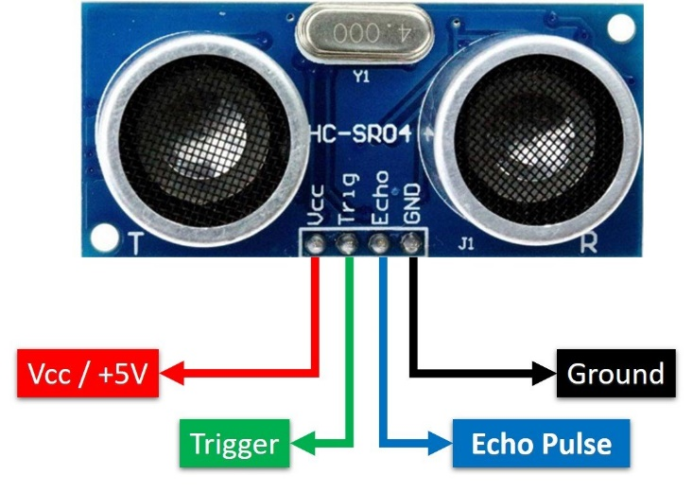

#define trigger_pin 9

#define Echo_pin 11

#define LED 13

long duration; or signed int duration;

int distance;

void setup() {

pinMode(trigger_pin, OUTPUT);

pinMode(LED, OUTPUT);

pinMode(Echo_pin, INPUT);

Serial.begin(9600);

}

void loop() {

digitalWrite(trigger_pin, LOW);

delayMicroseconds(2);

digitalWrite(trigger_pin, HIGH);

delayMicroseconds(10);

digitalWrite(trigger_pin, LOW);

duration = pulseIn(Echo_pin, HIGH);

distance= duration*0.034/2;

if ( distance < 10) digitalWrite(LED, HIGH);

else digitalWrite(LED, LOW);

Serial.print("Distance: ");

Serial.println(distance);

}